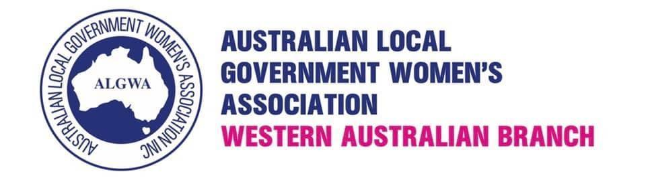
E: algwawa@outlook.com
W: www.algwawa.asn.au
ABN: 42 049 221 791

ALGWAWA 2023 AGM

Sunday 10th December 2023
12.30-1pm @ The Royal Hotel, Wellington Street, Perth

Minutes 2023
Meeting opened: 12.30pm
- Welcome, present and apologies :
Present : Deputy Mayor Lorna Buchan (Rockingham), Cr Brook O’Donnell (Kalamunda), Cr Serena Williamson (Gosnells), Mayor Teressa Lynes (Gosnells), Cr Diane Lloyd (Gosnells), Deputy Mayor Deborah Sessions (Belmont), Cr Jennifer Nevard (South Perth), Fatima Faqiri (Guest)

Via Zoom: President Laurene Bonza (Dundas), Cr Kelly Middlecoat (Rockingham), Cr Dawn Jecks (Rockingham), Cr Darlene Alston (Exmouth), Rebecca Privilege (Associate)

Apologies: Cr Liz Re (Stirling), Cr Alys McKeough (Upper Gascoyne), Mayor Laurene Bonza (Dundas), Chontelle Stone (Cockburn), Felicity Farrelley (Fmr Stirling), Anne Wood (Associate), Georgia Johnston (Bayswater), Lisa Thornton (Stirling).
- Minutes 2022 AGM
Motion: The minutes of the 2022 AGM are confirmed.
Moved: Cr Serena Williamson
Second: Cr Diane Lloyd
Carried
- Presidents Report-Mayor Teressa Lynes
- Thank you to the 2022/2023 committee
- Membership numbers - 44 current members/associates plus 4 life
- Mentornet program update
- Continuing relationship with sponsors (WALGA, LGIS)
- Admin support this year from Michelle
- Online events supporting women in the elections
- Restart of breakfast meetings held by members in local areas

- Life Membership - no nominations received.

- Treasurers Report- Deputy Mayor Lorna Buchan
Receipt of Income and Expenditure Account and Balance Sheet as at 30 June 2023.
Moved: Mayor Teressa Lynes
Second: Cr Serena Williamson
Carried

2024/245 Membership fees to remain (both Members and Associates) at $60
Moved: Deputy Mayor Lorna Buchan
Second: Mayor Teressa Lynes
Carried

- Elections - the following members were declared elected by the meeting
President - Cr Serena Williamson
Immediate Past President - Mayor Teressa Lynes
Vice President Metro - Cr Diane Lloyd
Vice President Country - Cr Darlene Alston
Treasurer - Deputy Mayor - Lorna Buchan
Secretary - Cr Brooke O’Donnell
Gen Com 1 membership - Cr Deborah Sessions
Gen Com 2 events - Cr Liz Re
Gen Com 3 grants - VACANT
Gen Com 4 - Cr Audra Smith
- General Business
- Next committee meeting to be scheduled in January at a date/time suitable to most members of the committee

- 2024 AGM
Date to be advised

Meeting closed: 1.00pm

