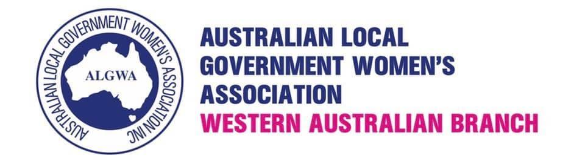
E: algwawa@outlook.com
W: www.algwawa.asn.au
ABN: 42 049 221 791

ALGWAWA 2021 AGM

Friday 19 November 2021
7:30am @ DOME Deep Water Point, Mt Pleasant

MINUTES
Meeting opened 7:36am
- Welcome and apologies
- apologies: Cr Amanda Lovitt
- Minutes 2020 AGM
Moved: Cr Janelle Sewell
Second: Cr Chontelle Stone
- Presidents Report- Cr Karen Wheatland
- Thank you to the 2020/2021 committee
- Challenges: structure change
Chontelle Stone- stepped down as treasurer and into Metro VP role
- Successful building of stakeholder relationships
New sponsors (LGIS), renewing sponsorship relationships with previous sponsors
- Treasurers Report- Debbie Whyte
- Account balance as of 18 November 2021
$69,311.61
- $41,000 to be quarantines for the MentorNet program
- Membership fees received
$3290
Moved: Cr Chontelle Stone
Second: Janelle Sewell
- Elections
President- Cr Chontelle Stone (elected unopposed)
Vice President Metro- Catherine Ehrhardt (elected unopposed)
Vice President Country- vacant
Treasurer- vacant (Debbie Whyte to continue as caretaker until position filled)
Secretary- vacant
Membership- vacant
Social Media- vacant
Committee- Janelle Sewell
Liz Re
Laurene Bonza
Marion Blair
Sue Bilich

- General Business
- Constitution Amendments- to be discussed before 2022 AGM, and implemented at 2022 AGM
- Motion: Consideration of womens only conference
Moved: Cr Karen Wheatland
Second: Cr Janelle Sewell

- 2022 AGM
Date to be set in conjunction with WALGA AGM and ALGWAWA Breakfast.

Meeting closed 8:28am

